**Integration of Jenkins with GitHub**

**~By Krishan Rupani**

**GitHub is**​ **a multinational corporation that provides hosting for software development**​  **and version control using Git.**

# Prerequisites

**● Jenkins running**

**In this module, we will see how to integrate Jenkins with GitHub.**

**Make sure your Jenkins is up and running.**

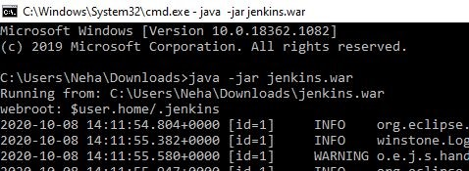

**Open jenkins in web browser, I will be using Chrome**

**“Localhost:8080”**

**On left-hand side, move to manage Jenkins.**

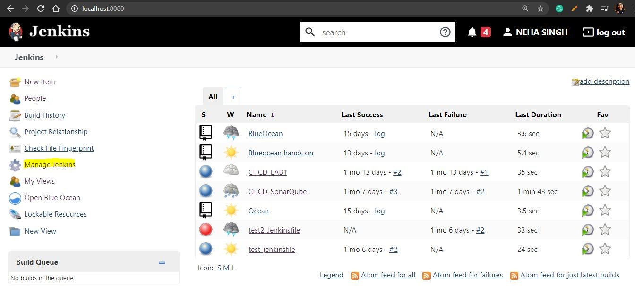

**Manage Plugins**

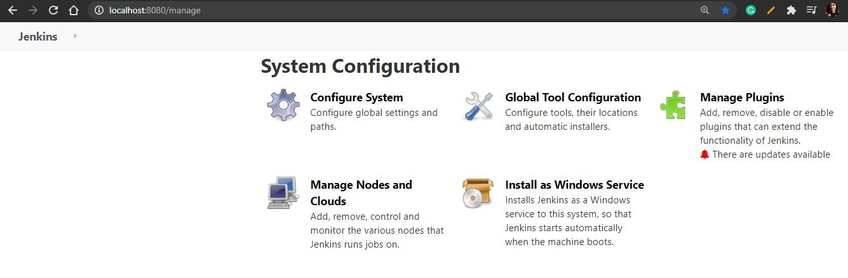

**Now, you can install Github Plugins**​



**If you do not have GitHub Account, move to** [**https://github.com**](https://github.com/)​ [**/**](https://github.com/)

**Enter credentials**

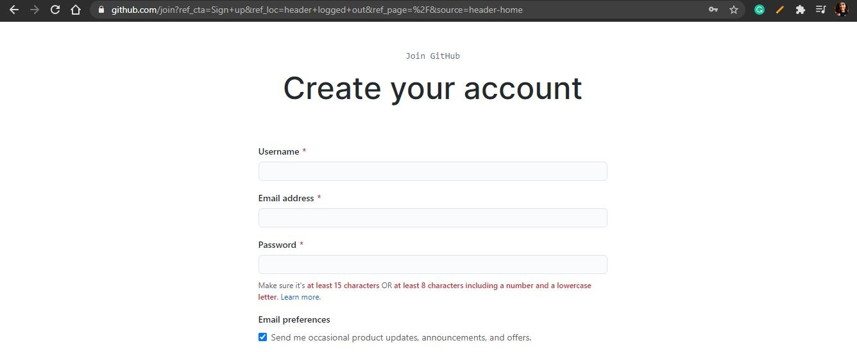

**You will see account like this but without repositories.**

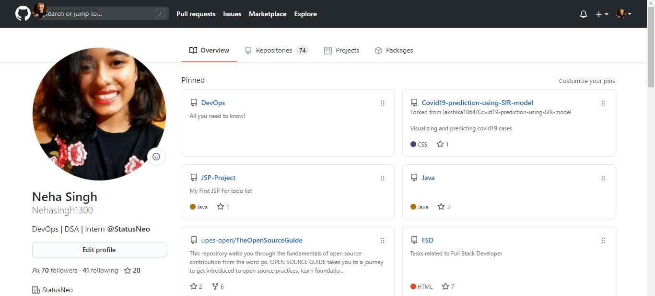

**Now, you can move to the upper right-hand side and click on + sign to make new repo.**

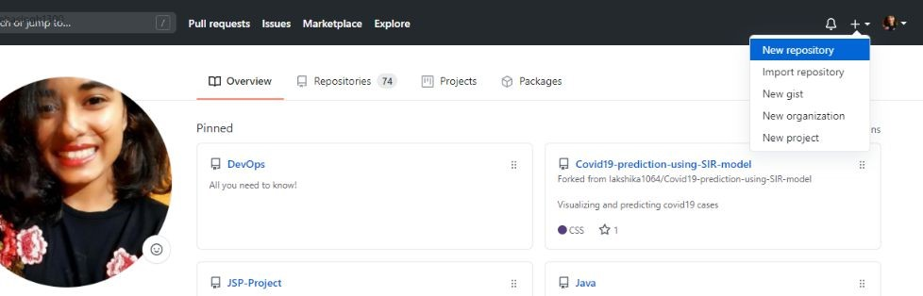

**You can enter any name for your repository, and description if you want. Then, go and click Create Repositiory**

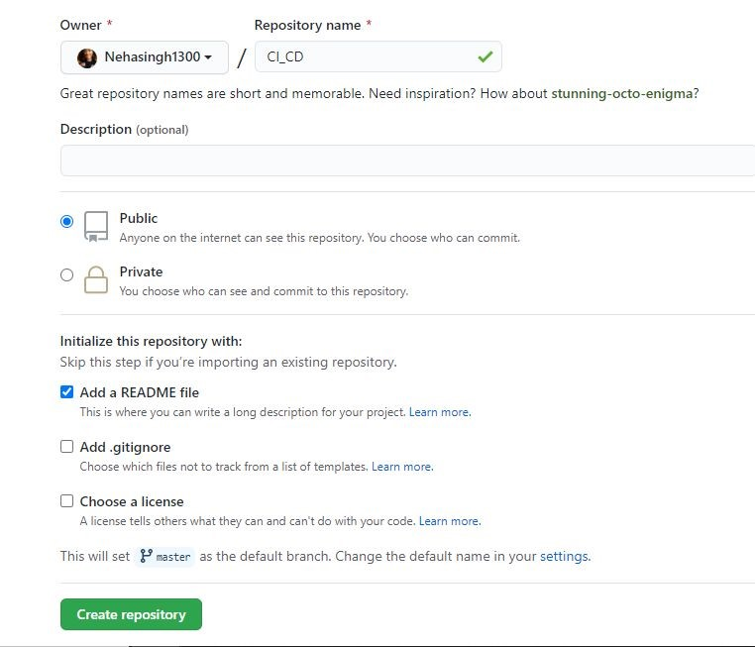

**You should have a pom.xml in the main folder and then add this code inside that file.**

**<project xmlns="http://maven.apache.org/POM/4.0.0" xmlns:xsi="http://www.w3.org/2001/XMLSchema-instance" xsi:schemaLocation="http://maven.apache.org/POM/4.0.0 http://maven.apache.org/xsd/maven-4.0.0.xsd">**

**<modelVersion>4.0.0</modelVersion>**

**<groupId>test.jenkinsfile</groupId>**

**<artifactId>test.jenkinsfile</artifactId>**

**<version>0.0.1-SNAPSHOT</version>**

**<properties>**

**<maven.compiler.source>1.6</maven.compiler.source>**

**<maven.compiler.target>1.6</maven.compiler.target>**

**</properties>**

**<distributionManagement>**

**<snapshotRepository>**

**<id>cicd</id>**

**<name>cicd</name>**

**<url>http://localhost:8081/repository/cicd/</url>**

**</snapshotRepository>**

**</distributionManagement>**

**</project>**

**Enter your code in GitHub. You can see all the changes in your repository.**

**Move to new items**

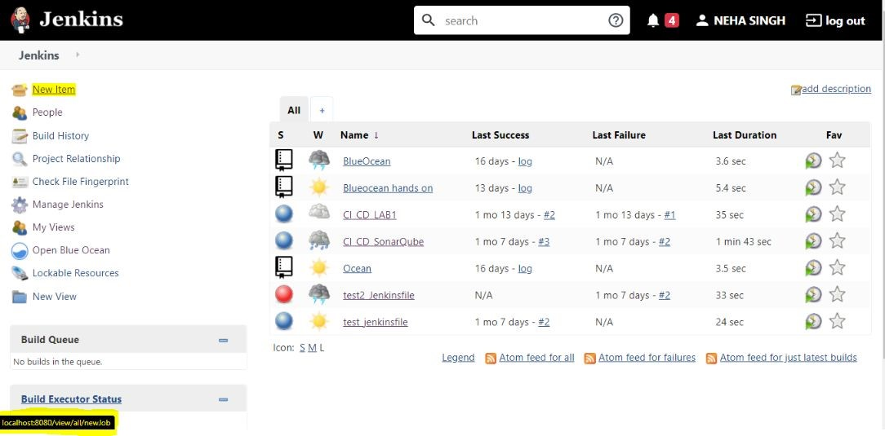

**Select Maven Project and enter the name of the project.**

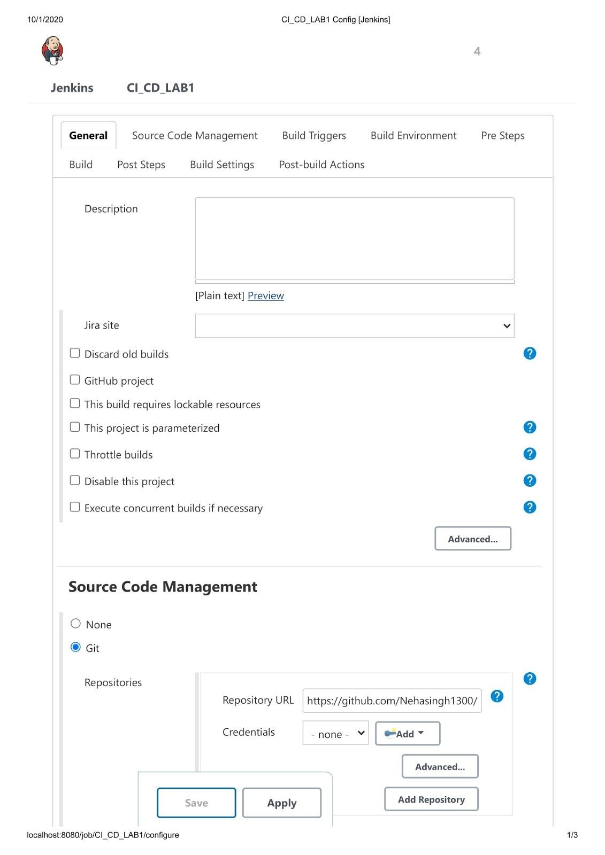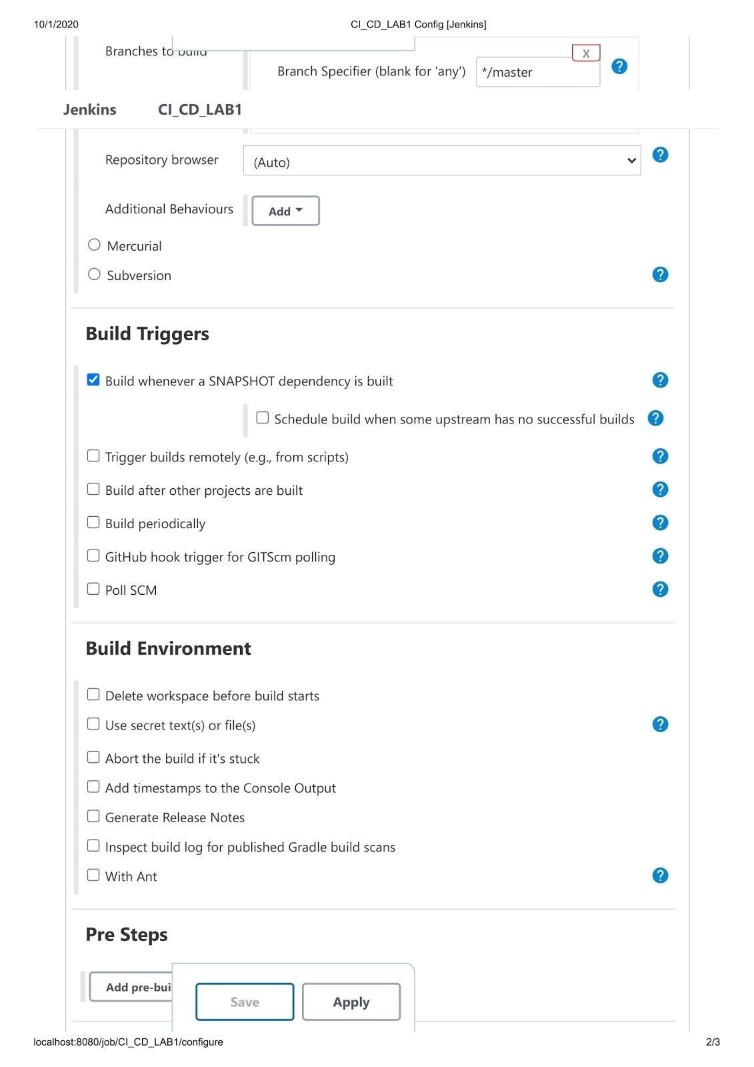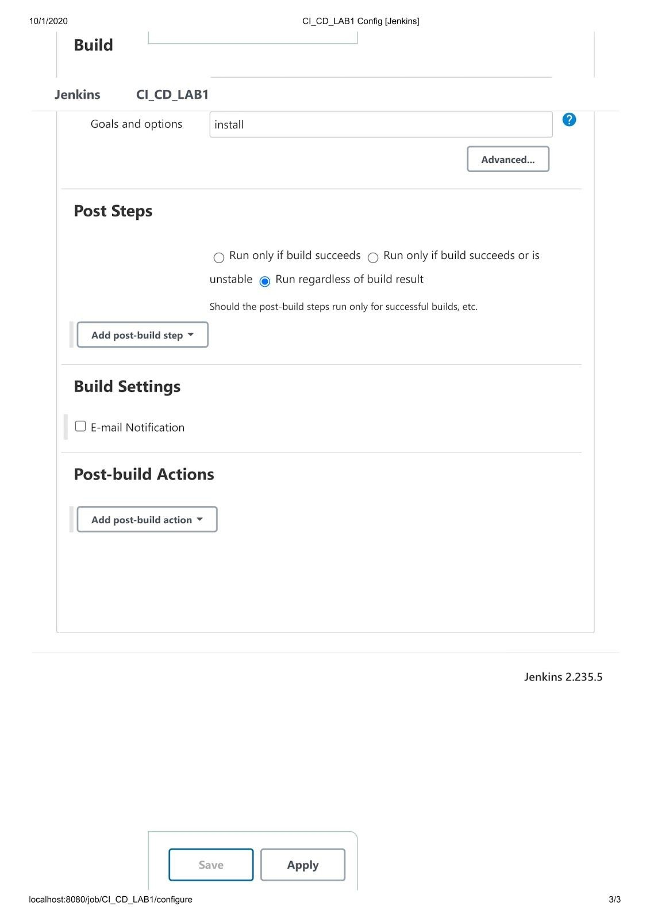

**Now, you can see your project. Click on Build now**

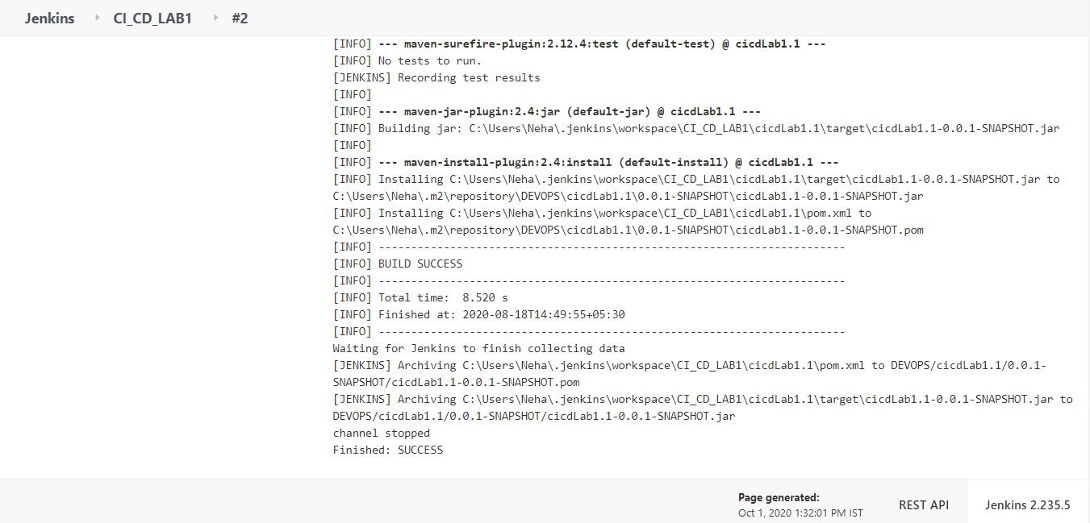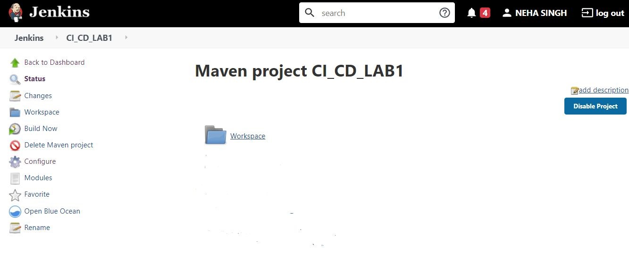

**You will be able to see Build Success if your project has no error, else go to the error message and make suitable changes.**

**You can see the build artifact**

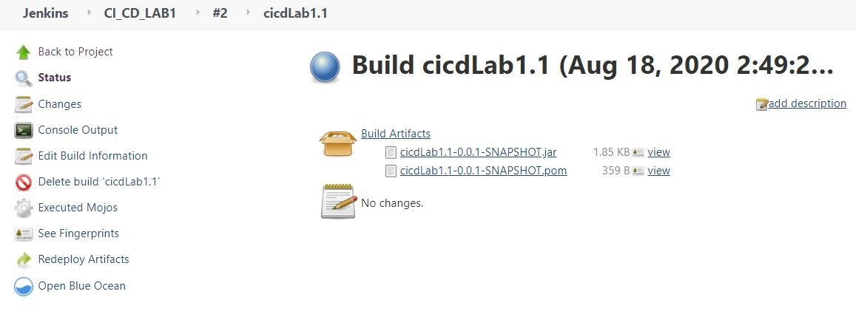

**That’s all for this module.**